Berried Treasure
Inspired by


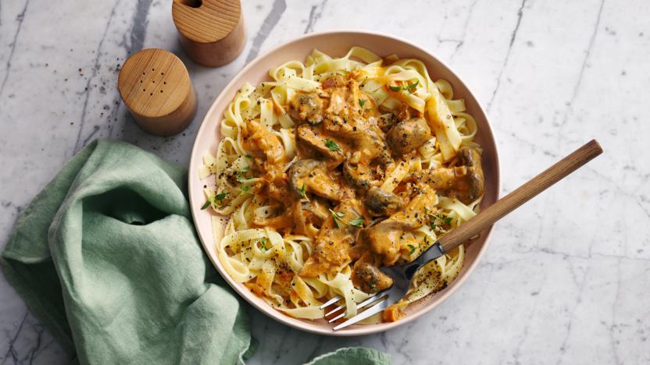
DID YOU KNOW?
“Blueberries have the highest concentration of antioxidants of any fruit. This helps protect against any diseases and delays deterioration of the body. So your body won’t be feeling blue for blueberries!”

Nutrition – Total / Per Cupcake
Calories: 1368kcal / 152kcal
Carbohydrates: 207g / 23g
Protein: 20g / 2.2g
Fat: 50g / 5.5g
Fibre: 5g / 0.5g
Sugar: 69g / 7.6g
Ingredients (makes ~9 cupcakes)
180g plain flour
50g sugar
120g (frozen) blueberries
195ml almond milk
50ml olive oil
½ tsp salt
1 tbsp lemon juice
2 tsp baking powder
2 tsp vanilla extract
1 tsp ground ginger
1 tsp ground cinnamon






Good for:

Star Rating:



Method

Step 1 – Get it Ready
Preheat the oven to 200 degrees C.
Line your muffin tray with liners or lightly grease.
Whisk the plain flour, sugar, salt, baking powder, ground ginger, and ground cinnamon together in a large bowl.

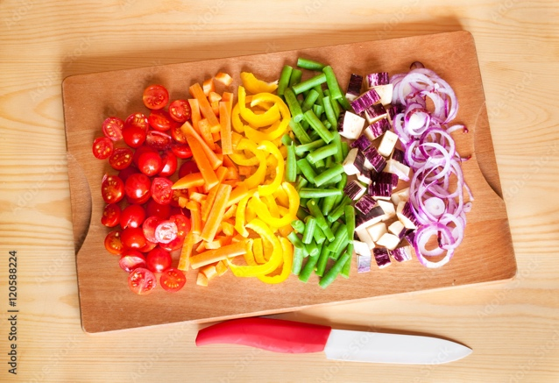

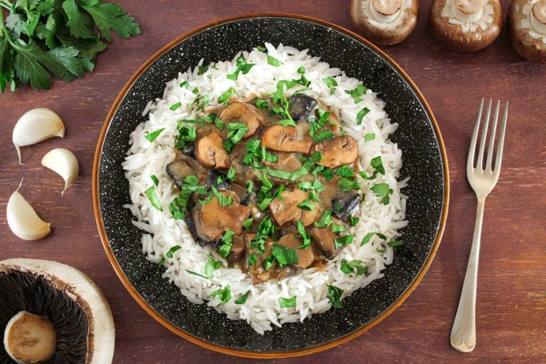
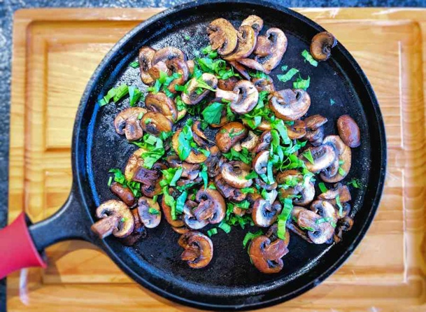
Sara’s favourite:
Mix 1tsp sugar with ½ tsp ground ginger and ½ tsp ground cinnamon and sprinkle on top of the muffins whilst they are still warm!
Step 2 – Keep it Moist
In another bowl, mix the almond milk, olive oil, lemon juice, and vanilla extract.
Slowly pour in the mixture of the wet ingredients into the large bowl with the dry ingredients, mixing until combined.
Once the batter has been combined, add in the blueberries.
Gently fold them in, be careful not to overmix or mix too hard.
Step 3 – Separate the Berries
With a tablespoon, spoon your batter into the muffin cups right to the top.
Bake for ~15 minutes or until lightly golden on the top.
Ensure that they are fully cooked through by inserting a knife/toothpick into the centre of the muffin and seeing if it comes out clean.
Allow to cool before transferring to an airtight container or even eating!

